|  |  |
| --- | --- |
| Course Name | ITD 2313 – Script Programming |
| Instructor | Mr. Pranger |
| Student Name | Trey Mobley |
| Due date | 05/26/2021 |
| Grade | <grade earned here> |
| Grading Comments | <instructor comments here> |

Page 65.

1,2

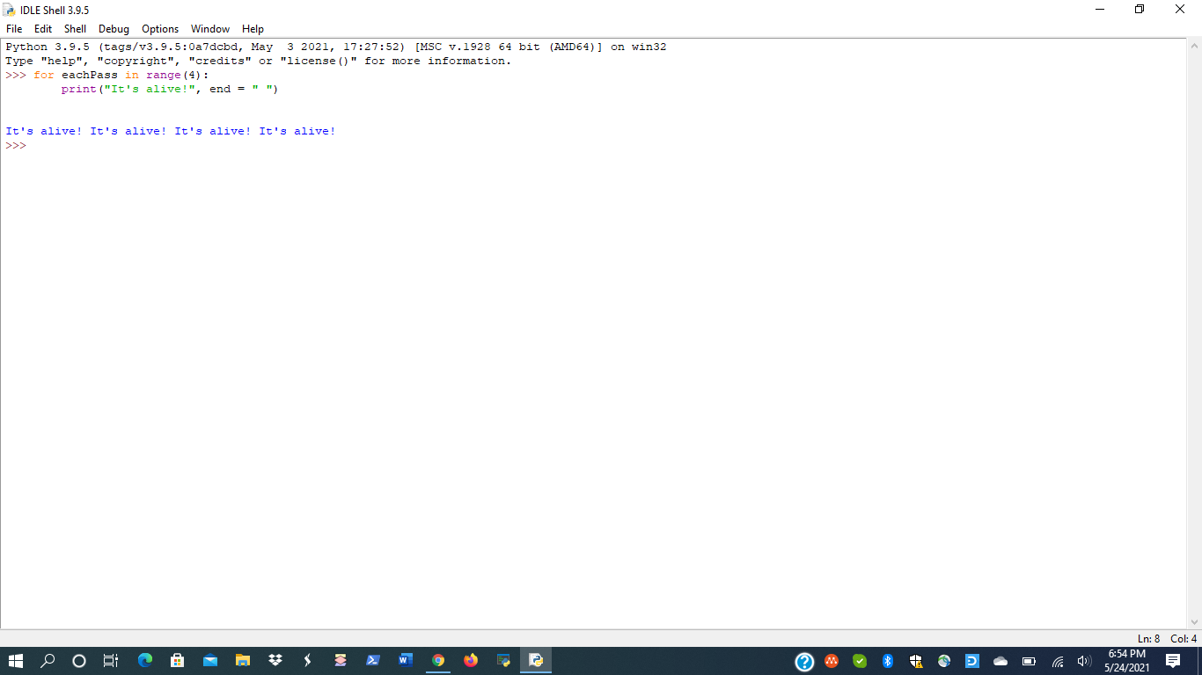

Page 66.

1.

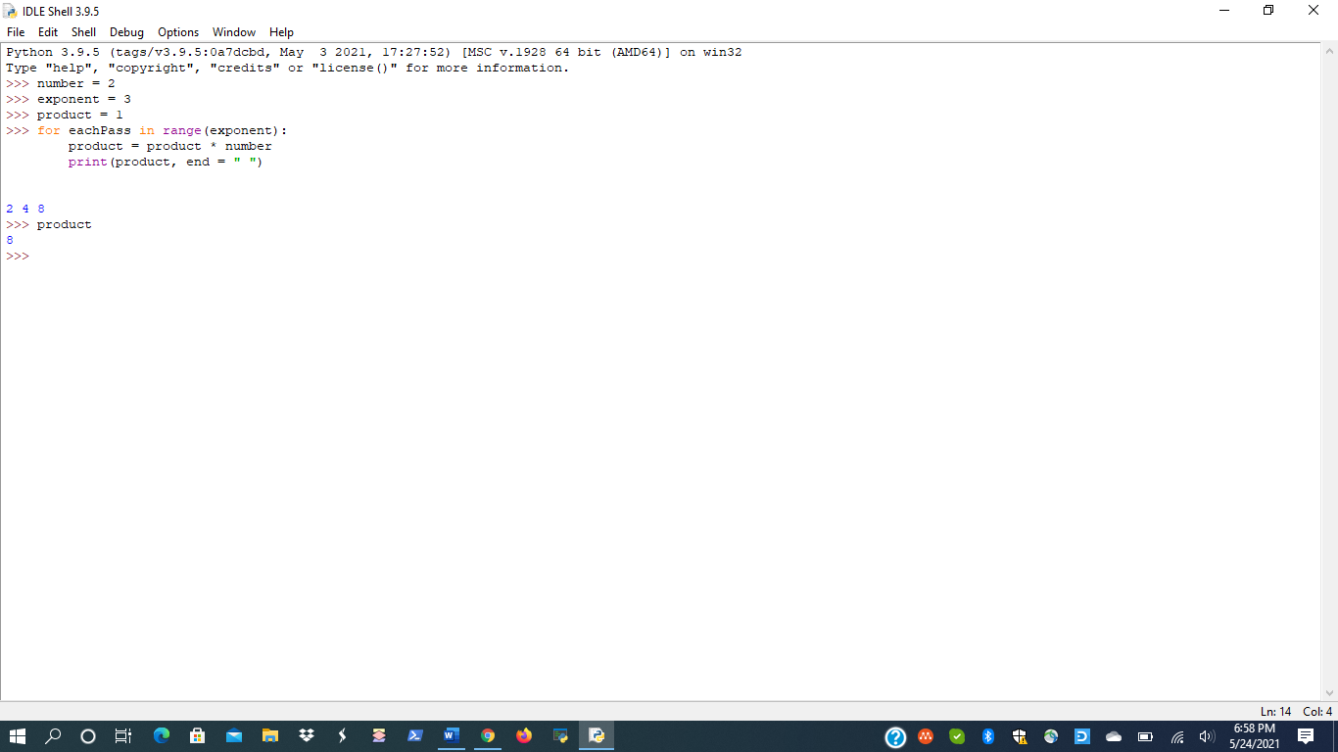

2.

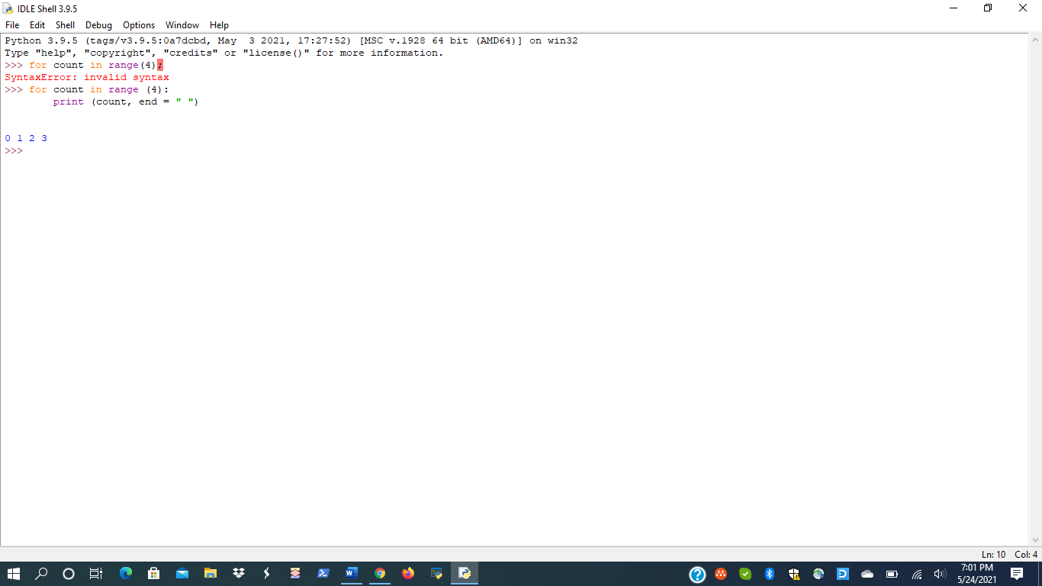

3.

Page 67.

1.

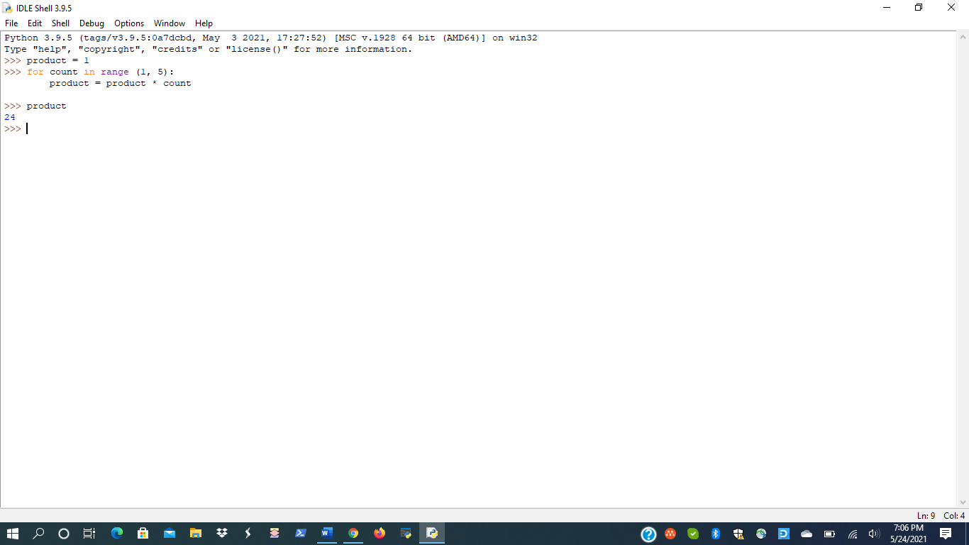

2.

3.

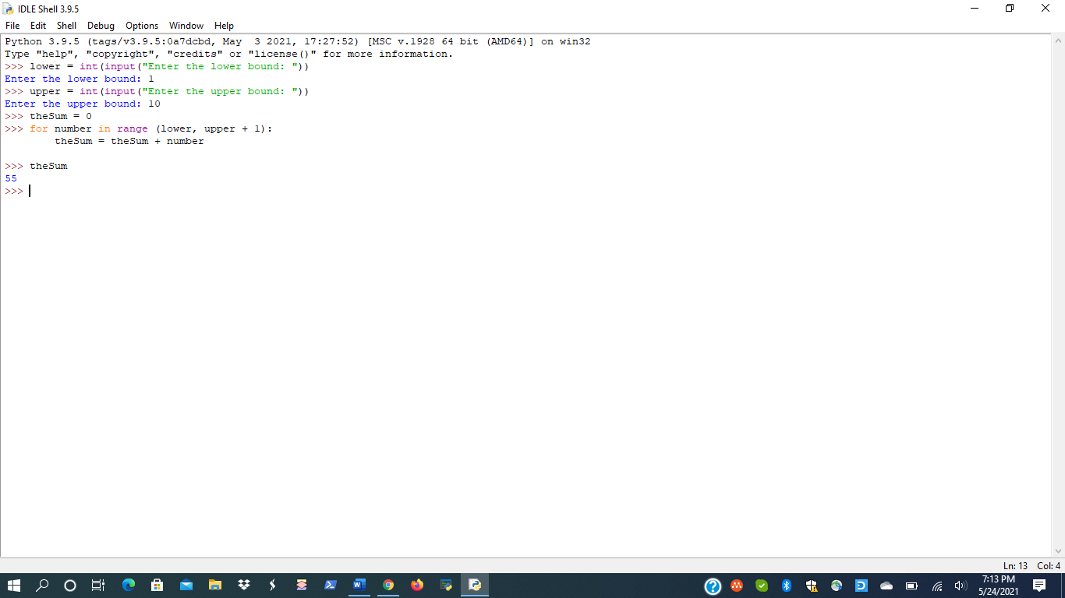

Page 68.

1.

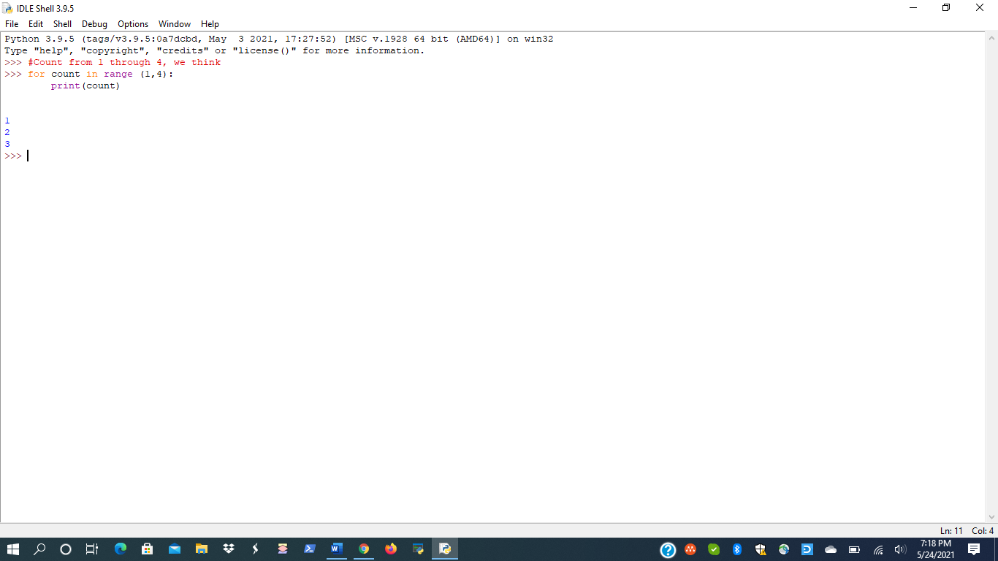

2.

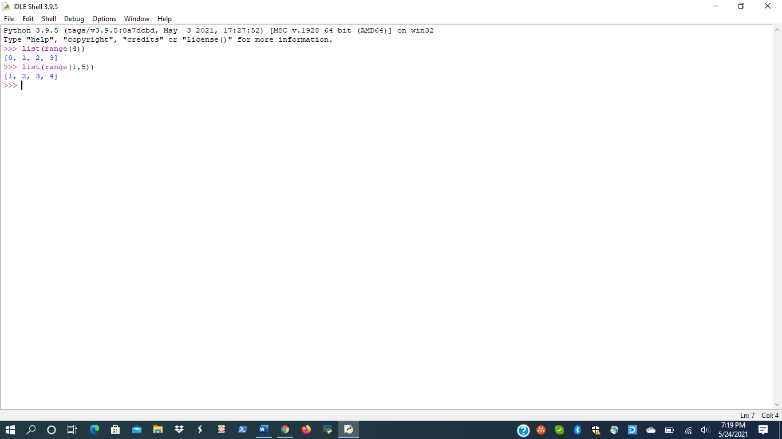

Page 69

1.

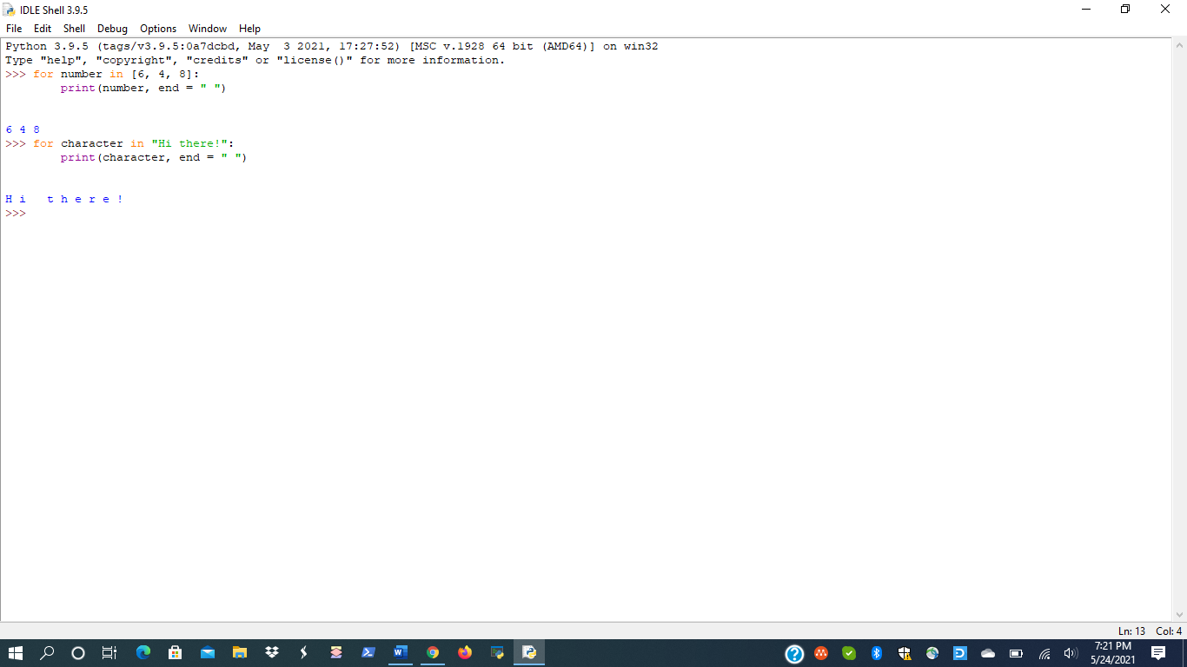

2.

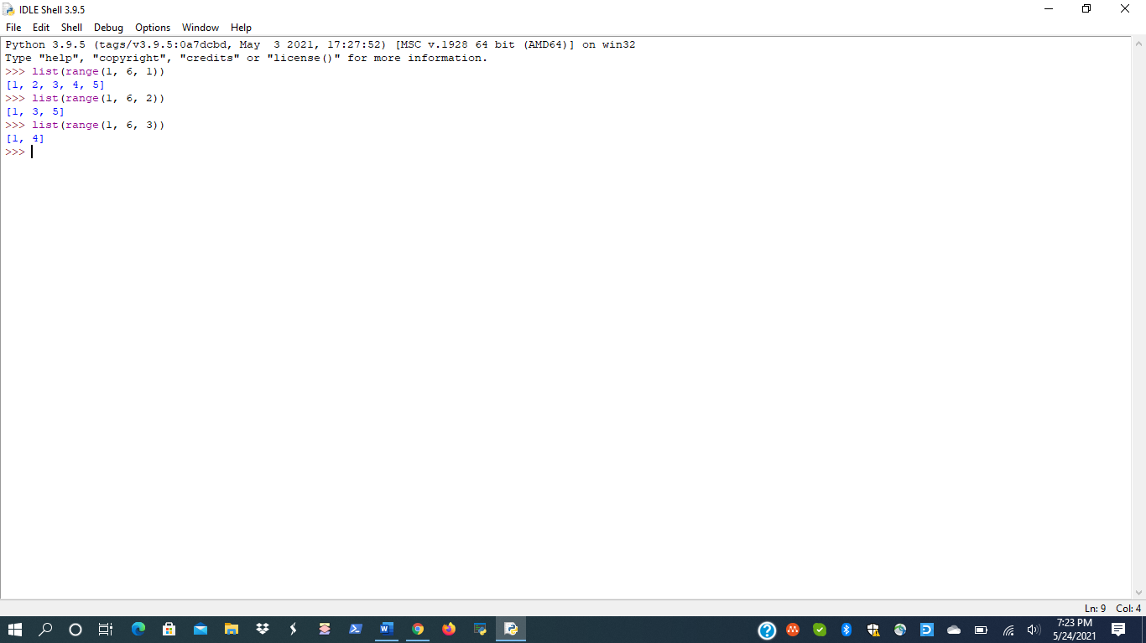

3.

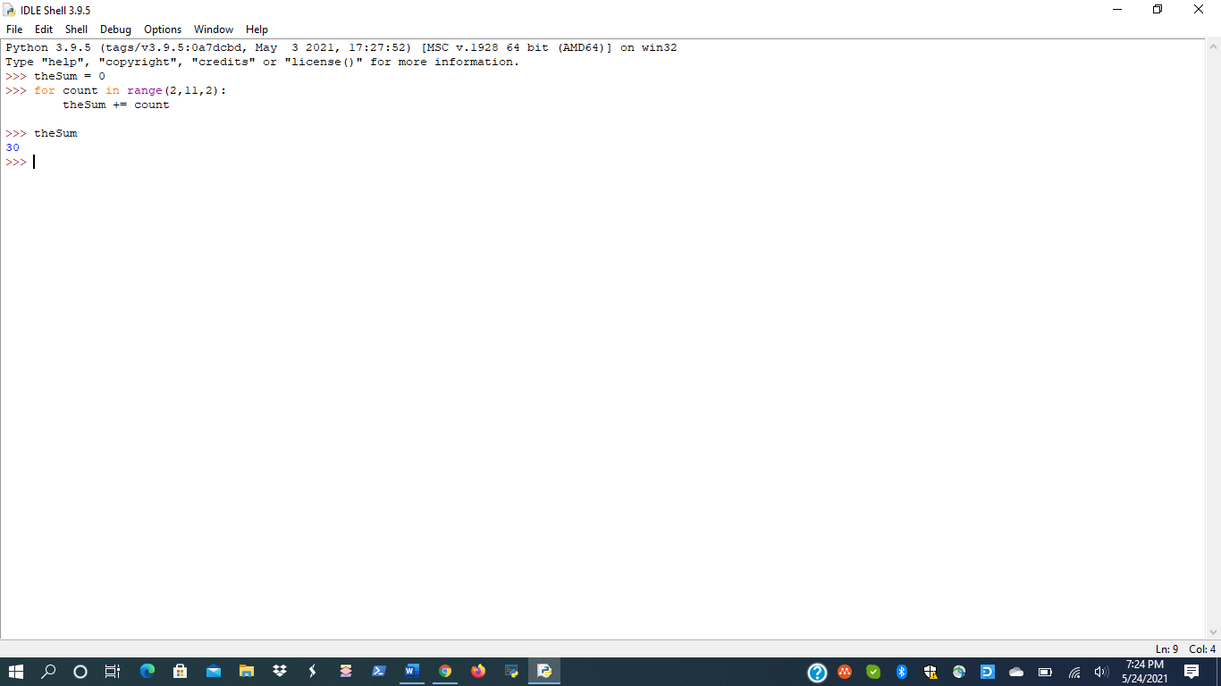

4.

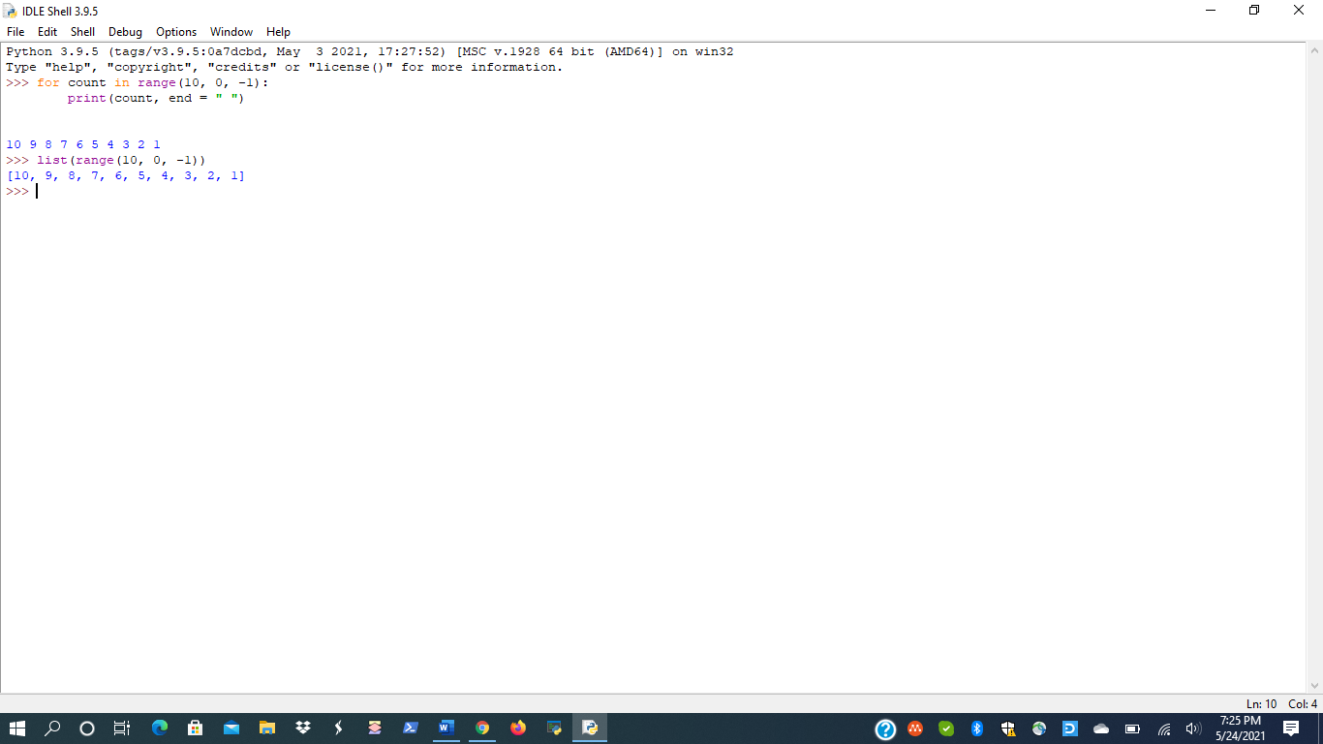

Page 71.

1.

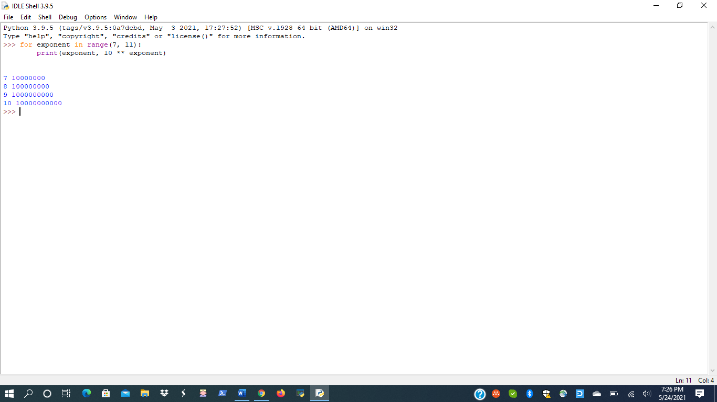

2.

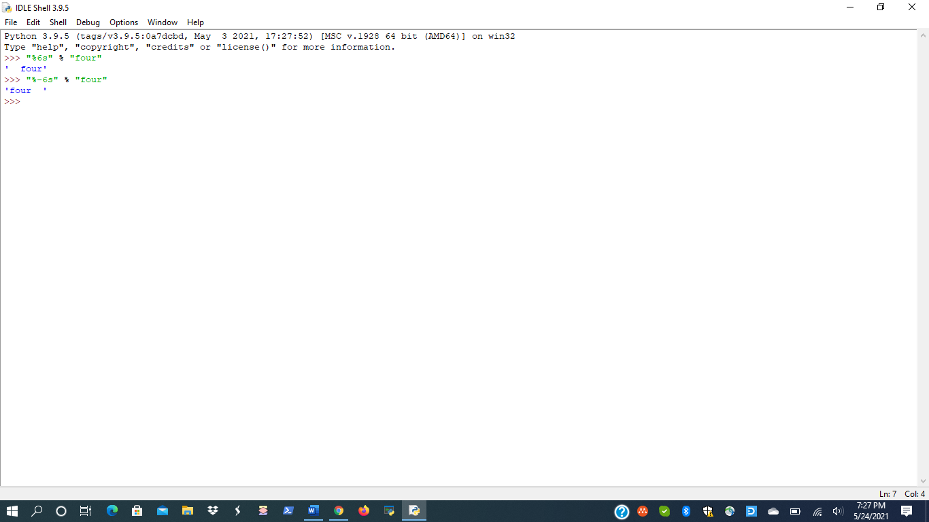

Page 72.

1.

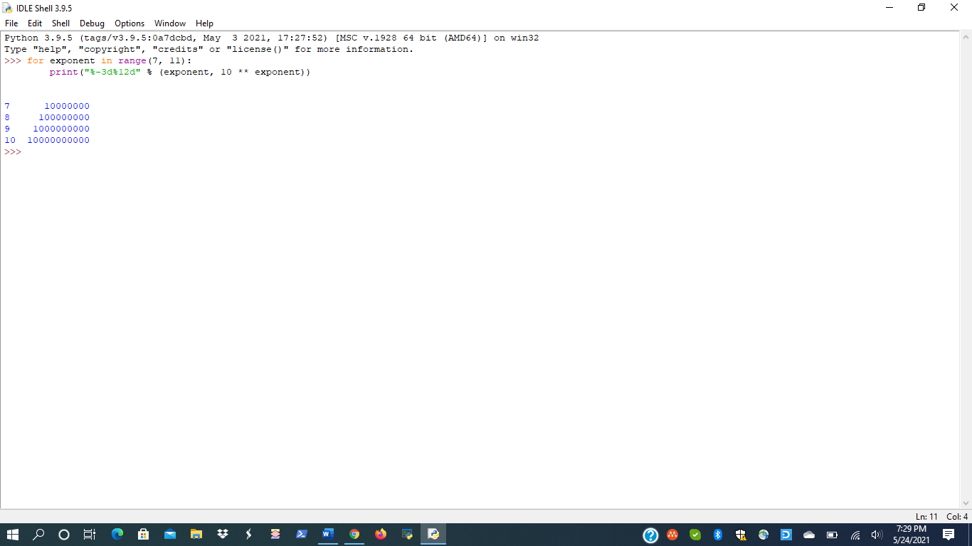

2.

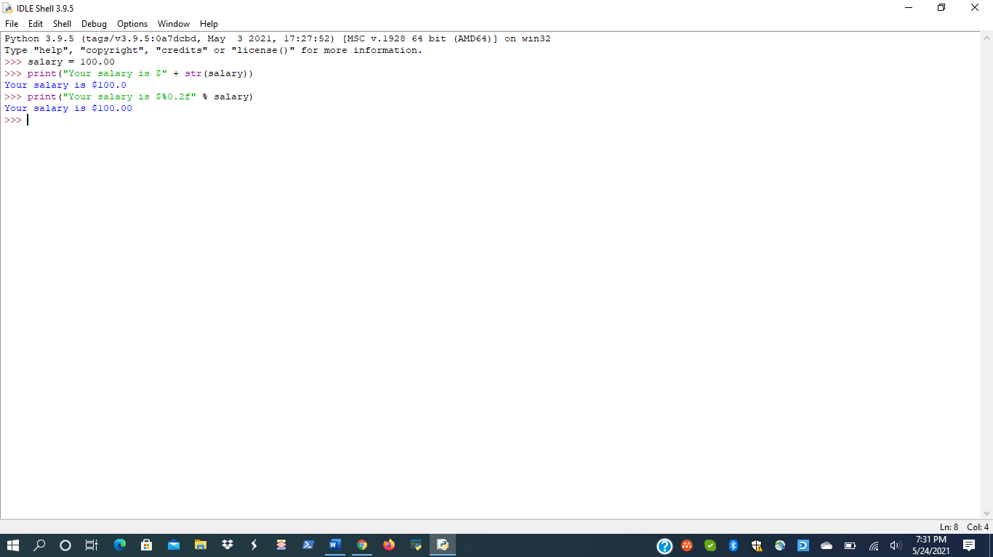

3.

